

Journal of Peace and Conflict Research
Journal homepage: http://cbu.ac.zm/cbujournals/

Journal of Peace and Conflict Research; x(x) (2026) xxx-xxx

Type the Title of Your Paper, Capitalize First Letter from Each Word Except for the Following List (at, around, by, after, along, for, from, of, on, to, with, without, for, and, nor, but, or, yet, so, a, an, & the) (Use 18 Times New Roman; Bold)
First name followed by family name for the first author, First name follwoed by family name for the second author (use 14 times new roman)
First author affiliation, Address, City and Postcode, Country (use 10 times new roman; italic)
Second author affiliation, Address, City and Postcode, Country
Email: example@yahoo.com
Email: example@yahoo.com

A B S T R A C T |  | A R T I C L E I N F O
(Use 10 point font, times new roman) The template is used to format your paper and style the text. All margins, column widths, line spaces, and text fonts are prescribed; please do not alter them. Paper size is A4 (page layout sizeA4). Use the normal margins (page layout marginsnormal). Paragraph sittings (paragraphline spacing 1.5, after and before the paragraph is automatic). |  | Article History:  Submitted/Received 00 xxx 2026  First Revised 00 xxx 2026  Accepted 00 xxx 2026  First Available online 00 xxx 2026  Publication Date 00 xxx 2026  ____________________  Keywords: Type your keywords here; separated by semicolons (;)

1. INTRODUCTION (use bold for main headings like this one. do not use italic)
(Use 10 point font, times new roman) Here introduce the paper. The paragraphs continue from here and are only separated by headings, subheadings, images and formulae. The section headings are arranged by numbers, bold and 10 pt. Here follows further instructions for authors.
Structure (use italic and bold for subheadings like this one)
Files should be in MS Word format only and should be formatted for direct printing. Figures and tables should be embedded and not supplied separately.
Please make sure that you use as much as possible normal fonts in your documents. Special fonts, such as fonts used in the Far East (Japanese, Chinese, Korean, etc.) may cause problems during processing. To avoid unnecessary errors you are strongly advised to use the ‘spellchecker’ function of MS Word.
Follow this order when typing manuscripts: Title, Authors, Affiliations, Abstract, Keywords, introduction, materials and methods, results, conclusion, Acknowledgements, References, Appendix. Collate acknowledgements in a separate section at the end of the article and do not include them on the title page.
Bulleted lists may be included and should look like this:
First point
Second point
And so on
Please do not alter the formatting and style layouts which have been set up in this template document. As indicated in the template, papers should be prepared in single column format suitable for direct printing onto A4 paper (8.3in x 11.7in/210mm x 297mm). Leave a line clear between paragraphs.
Tables (tables should start and end within the same page unless the table is longer than one page)
All tables should be numbered with Arabic numerals. Headings should be placed above tables, center justified. 10pt font size. Leave one line space between the heading and the table. Tables must be embedded into the text and not supplied separately. Below is an example which authors may find useful.
Table 1: An example of a table
An example of a column heading | Column A (t) | Column B (T)
And an entry | 1 | 2
And another entry | 3 | 4
And another entry | 5 | 6
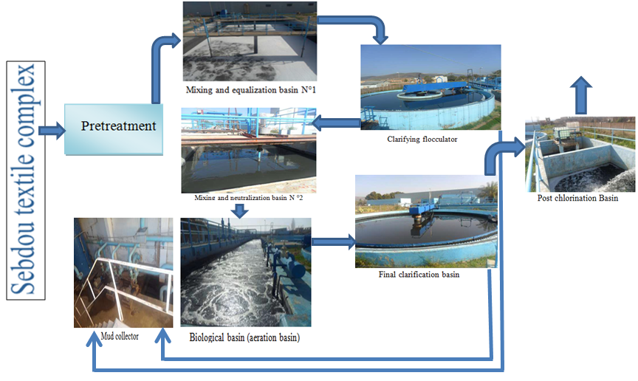

Figure 1. Schematic diagram of the physicochemical treatment process in the station of the textile industrial unit.
Section headings
Section headings should be left justified, with the first letter capitalized and numbered consecutively, starting with the Introduction. Sub-section headings should be in capital and lower-case italic letters, numbered 1.1, 1.2, etc, and left justified, with second and subsequent lines indented.
General guidelines for the preparation of your text
Weights and measures should be expressed in either SI (MKS) or CGS as primary units. (SI units are encouraged.).
Figures and equations (do not use write figure as Fig.)
All figures should be numbered with Arabic numerals (1,2,...n). All photographs, schemas, graphs and diagrams are to be referred to as figures. Figures must be embedded into the text and not supplied separately. Lettering and symbols should be clearly defined either in the caption or in a legend provided as part of the figure.
The figure number and caption should be typed below the illustration in 10pt and center justified.
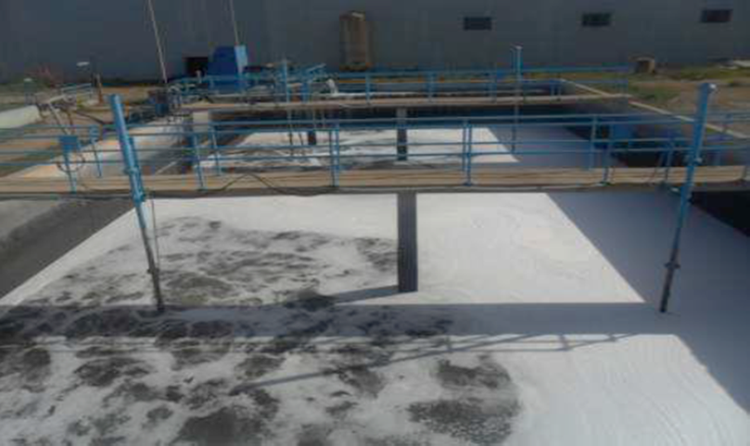
Figure 1: first picture
Equations and formulae should be typed and numbered consecutively with Arabic numerals in parentheses on the right hand side of the page (if referred to explicitly in the text).
Acknowledgements (use 10 point font, times new roman)
These and the Reference headings are in bold. Text below continues as normal.
Construction of references
References should be listed at the end of the paper, and numbered in the order of their appearance in the text. Authors should ensure that every reference in the text appears in the list of references and vice versa. Indicate references by numbers in the text. In the text the number of the reference should be given in square brackets [3]. The actual authors can be referred to, but the reference number(s) must always be given.
Some examples of how your references should be listed are given at the end of this template in the ‘References’ section which will allow you to assemble your reference list according to the correct format and font size. There is a shortened form for last page number. e.g., 51–9, and that for more than 6 authors the first 6 should be listed followed by “et al.”
References (use 10 point font, times new roman)

Print References

Book:
Author(s). Book title. Location: Publishing company, year, pp.
Example:
W.K. Chen. Linear Networks and Systems. Belmont, CA: Wadsworth, 1993, pp. 123-35.

Book Chapters
Author(s). “Chapter title” in Book title, edition, volume. Editors name, Ed. Publishing location: Publishing company, year, pp.
Example:
J.E. Bourne. “Synthetic structure of industrial plastics,” in Plastics, 2nd ed., vol. 3. J. Peters, Ed. New York: McGraw-Hill, 1964, pp.15-67.

Article in a Journal
Author(s). “Article title”. Journal title, vol., pp, date.
Example:
G. Pevere. “Infrared Nation.” The International Journal of Infrared Design, vol. 33, pp. 56-99, Jan. 1979.
Articles from Conference Proceedings (published) Author(s). “Article title.” Conference proceedings, year, pp.
Example:
D.B. Payne and H.G. Gunhold. “Digital sundials and broadband technology,” in Proc. IOOC-ECOC, 1986, pp. 557-998.
Papers Presented at Conferences (unpublished) Author(s). “Paper’s title,” Conference name, Location, year.
Example:
B. Brandli and M. Dick. “Engineering names and concepts,” presented at the 2nd Int. Conf. Engineering Education, Frankfurt, Germany, 1999.

Standards/Patents
Author(s)/Inventor(s). “Name/Title.” Country where patent is registered. Patent number, date.
Example:
E.E. Rebecca. “Alternating current fed power supply.” U.S. Patent 7 897 777, Nov. 3, 1987.

Electronic References

Books
Author. (year, Month day). Book title. (edition). [Type of medium]. Vol. (issue). Available: site/path/file [date accessed].
Example:
S. Calmer. (1999, June 1). Engineering and Art. (2nd edition). [On-line]. 27(3). Available:
www.enggart.com/examples/students.html [May 21, 2003].
Journal
Author. (year, month). “Article title.” Journal title. [Type of medium]. Vol. (issue), pages. Available: site/path/file [date accessed].
Example:
A. Paul. (1987, Oct.). “Electrical properties of flying machines.” Flying Machines. [On- line]. 38(1), pp. 778-998. Available: www.flyingmachjourn/properties/fly.edu [Dec. 1,
2003].

World Wide Web
Author(s)*. “Title.” Internet: complete URL, date updated* [date accessed].
Example:
M. Duncan. “Engineering Concepts on Ice. Internet: www.iceengg.edu/staff.html, Oct. 25, 2000 [Nov. 29, 2003].

Odd Sources

Newspaper
Author(s)*. “Article title.” Newspaper (month, year), section, pages.
Examples:
B. Bart. “Going Faster.” Globe and Mail (Oct. 14, 2002), sec. A p.1. “Telehealth in Alberta.” Toronto Star (Nov. 12, 2003), sec. G pp. 1-3.

Dissertations and Theses
Author. “Title.” Degree level, school, location, year.
Example:
S. Mack. “Desperate Optimism.” M.A. thesis, University of Calgary, Canada, 2000.

Lecture
Lecturer(s). Occasion, Topic: “Lecture title.” Location, date.
Example:
S. Maw. Engg 251. Class Lecture, Topic: “Speed skating.” ICT 224, Faculty of Engineering, University of Calgary, Calgary, Alberta, Oct. 31, 2003.

E-mail
Author. Subject line of posting. Personal E-mail (date).
Example:
J. Aston. “RE: new location, okay?” Personal e-mail (Jul. 3, 2003).

Internet - Newsgroup
Author or Topic*, “Title,” Complete network address, date when it was updated [date accessed].
Example:
G.G. Gavin. “Climbing and limb torsion #3387,” USENET: sci.climb.torsion, Apr. 19, 2000 [Oct. 4, 2002].
* if you can’t find this information, exclude it.

Exact page number References
To refer readers to specific page numbers in a text, use the number of the reference followed by a colon (:) and the page numbers.
Example:
Johnson suggests that citing will lead to a decrease in being cited for plagiarism [1:28- 29].
The [1] refers to the numbered reference
And the 28-29 refers to the pages being cited.

