
The Title of Your Paper: With Proper Capitalization
Author 11∗, Author 21
1First Author Affiliation, Address, City and Postcode, Country
2Second Author Affiliation, Address, City and Postcode, Country Email: example1@yahoo.com Email: example2@yahoo.com

Abstract
∗Corresponding Author: example1@yahoo.com ORCID: https://orcid.org/0000-0024-8785-794X

The abstract goes here. It should be concise and summarize the key points of the paper, including objectives, methods, results, and conclusions. The abstract is a single para-graph without headings, reference citations and should not be more than 250 words.

Keywords: Type your keywords here; separated by semicolons (;) Bio-polymer; Bio-plastics; Polyhydroxy-butyrate(PHB)

INTRODUCTION
Here, introduce the paper. The paragraphs continue from here and are only separated by headings, subheadings, images and formulae. The section headings are arranged by numbers, bold and 12 pt. All in-text citation should be as numbering citation for each of the references [1], [1,2,3].

Structure

Sub-headings are italic and bold, numbered 1.1, 1.2, etc., left justified, second and subsequent lines indented if needed.
Files should be in MS Word format only and should be formatted for direct printing. Figures and tables should be embedded and not supplied separately.
Please make sure that you use as much as possible normal fonts in your documents. Special fonts, such as fonts used in the Far East (Japanese, Chinese, Korean, etc.) may cause problems during processing. To avoid unnecessary errors you are strongly advised to use the ‘spellchecker’ function of MS Word.
Follow this order when typing manuscripts: Title, Authors, Affiliations, Abstract, Key-words, Introduction, Materials and Methods, Results and Discussion, Conclusion, Acknowledgements, References, Appendix.
Collate acknowledgements in a separate section at the end of the article and do not include them on the title page.
Bulleted lists may be included and should look like this:

- First point

- Second point

- And so on

Please do not alter the formatting and style layouts which have been set up in this template document. As indicated in the template, papers should be prepared in single column format suitable for direct printing onto A4 paper (8.3 in × 11.7 in / 210 mm × 297 mm). Leave a line clear between paragraphs.
Font type is preferably Times New Roman, 12pt, 1.5 spacing, with no space below or under the text.

Tables

All tables should follow the number sequence, not the section number and each of the table No. should be cited in the text. Tables should start and end within the same page unless the table is longer than one page. All tables should be numbered with Arabic numerals. Headings should be placed above tables, center justified, 10 pt font size. Leave one line space between the heading and the table. Tables must be embedded into the text and not supplied separately (Table. 1).
Table 1: An example of a table

An example of a column heading | Column A (t) | Column B (T)
And an entry | 1 | 2
And another entry | 3 | 4
And another entry | 5 | 6

Figures

All Figures should follow the number sequence, not the section number and each of the Figure No. should be cited in the text. Figures should be numbered with Arabic numerals (1, 2, 3. ). All photographs, schemas, graphs and diagrams are to be referred
to as figures. Figures must be embedded into the text and not supplied separately (Figure. 1). Lettering and symbols should be clearly defined either in the caption or in a legend provided as part of the figure.
The figure number and caption should be typed below the illustration in 10 pt and center justified.
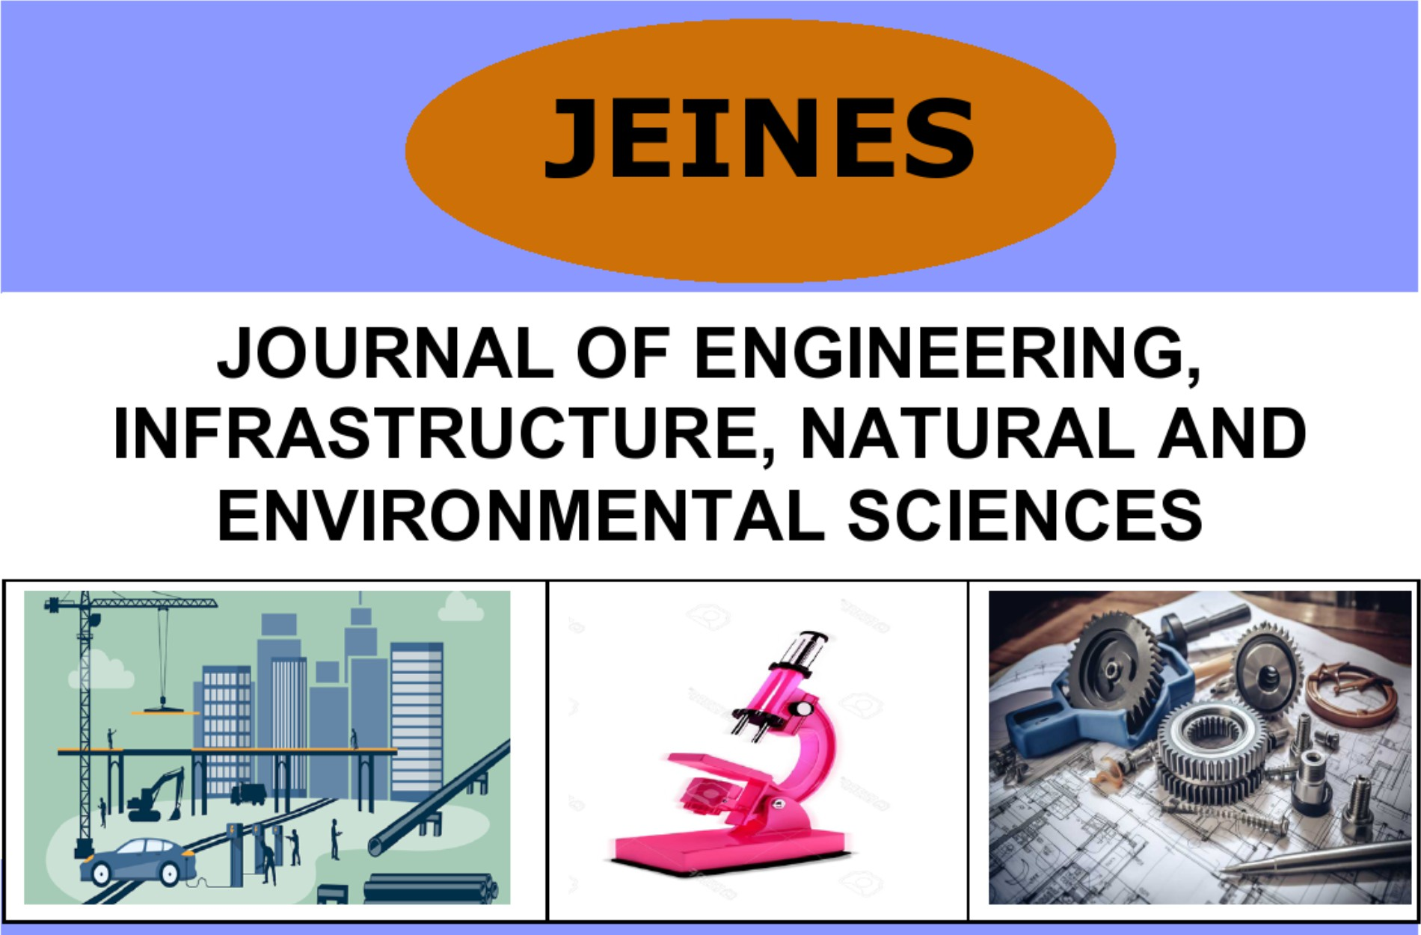
Figure 1: An example of a figure

Equations and formulae

Equations and formulae should be typed and numbered consecutively with Arabic nu-merals in parentheses on the right-hand side of the page (if referred to explicitly in the text).

E = mc² (1)

MATERIALS AND METHODS
This section describes the materials and methods used in the study. Follow the same formatting as the Introduction.

RESULTS AND DISCUSSION
Present the results and discussion of your research here. Use tables and figures as needed to illustrate your findings and discuss with other researchers findings with references.

CONCLUSION
Summarize the main conclusions of the work. Highlight the significance and possible implications.

Acknowledgements
This section is optional. Collate acknowledgements in a separate section at the end of the article and do not include them on the title page. Text below continues as normal.

References

- Author(s). Book title. Location: Publishing company, year, pp.

- Author(s). “Article title”. Journal title, vol., pp, date.

- Author(s). “Paper’s title,” Conference name, Location, year.

Appendix
Optional appendix material can be placed here.

